

Semester One Examination, 2019

Question/Answer booklet

MATHEMATICS

SOLUTIONS
METHODS
UNIT 1

Section One:

Calculator-free

Student number: In figures

In words

Your name

Time allowed for this section
Reading time before commencing work: five minutes
Working time: fifty minutes

Materials required/recommended for this section
To be provided by the supervisor
This Question/Answer booklet
Formula sheet

To be provided by the candidate
Standard items: pens (blue/black preferred), pencils (including coloured), sharpener,
correction fluid/tape, eraser, ruler, highlighters

Special items: nil

Important note to candidates
No other items may be taken into the examination room. It is your responsibility to ensure that you do not have any unauthorised material. If you have any unauthorised material with you, hand it to the supervisor before reading any further.

Structure of this paper

Section | Number of questions available | Number of questions to be answered | Working  time (minutes) | Marks available | Percentage of examination
Section One:  Calculator-free | 8 | 8 | 50 | 52 | 35
Section Two:  Calculator-assumed | 13 | 13 | 100 | 98 | 65
 |  |  |  | Total | 100

Instructions to candidates

1. The rules for the conduct of examinations are detailed in the school handbook. Sitting this examination implies that you agree to abide by these rules.

2. Write your answers in this Question/Answer booklet preferably using a blue/black pen.
Do not use erasable or gel pens.

3. You must be careful to confine your answer to the specific question asked and to follow any instructions that are specified to a particular question.

4. Show all your working clearly. Your working should be in sufficient detail to allow your answers to be checked readily and for marks to be awarded for reasoning. Incorrect answers given without supporting reasoning cannot be allocated any marks. For any question or part question worth more than two marks, valid working or justification is required to receive full marks. If you repeat any question, ensure that you cancel the answer you do not wish to have marked.

5. It is recommended that you do not use pencil, except in diagrams.

6. Supplementary pages for planning/continuing your answers to questions are provided at the end of this Question/Answer booklet. If you use these pages to continue an answer, indicate at the original answer where the answer is continued, i.e. give the page number.

7. The Formula sheet is not to be handed in with your Question/Answer booklet.
Section One: Calculator-free 35% (52 Marks)
This section has eight (8) questions. Answer all questions. Write your answers in the spaces provided.

Working time: 50 minutes.

Question 1 (5 marks)
Solve the following equations for $x$.

(a) $\left(2x-9\right)\left(x+7\right)=0$. (1 mark)
Solution
$$x=4.5, x=-7$$

Specific behaviours
✓ both correct solutions

(b) $\begin{matrix}x \\ \overline{3}\end{matrix}=\begin{matrix}2x-1 \\ \overline{ 2 }\end{matrix}$. (2 marks)
Solution
$$2x=6x-3$$

$$4x=3⇒x=\frac{3}{4}$$

Specific behaviours
cross multiplies
✓ correct solution

(c) $4x^{2}=4x$. (2 marks)
Solution
$$4x\left(x-1\right)=0$$

$$x=0, x=1$$

Specific behaviours
one correct solution
✓ both correct solutions

Question 2 (6 marks)
(a) A circle of radius $4$ has its centre at the point $(-2, 3)$. Determine the equation of the circle in the form $x^{2}+y^{2}=ax+by+c$. (3 marks)
Solution
$${\left(x+2\right)}^{2}+{\left(y-3\right)}^{2}=4^{2}$$

$$x^{2}+4x+4+y^{2}-6y+9=16$$

$$x^{2}+y^{2}=-4x+6y+3$$

Specific behaviours
writes equation of circle
✓ correctly expands
✓ writes in required form

(b) The graph of $x=y^{2}$ passes through the point $(4, q)$. Determine the value(s) of $q$ and hence explain why $y$ is a relation but not a function of $x$. (3 marks)
Solution
$$4=q^{2}⇒q=±2$$

A relation exists as we are told that $x=y^{2}.$

The relation is not a function because it is not one-to-one (for most values of $x$ there is more than one value of $y$).

Specific behaviours
both possible values
✓ explains relation between variables
✓ explains why relation not a function

Question 3 (6 marks)
(a) The graph of $y=a\cos{(x+b)}$ is shown below, where $a$ and $b$ are constants.

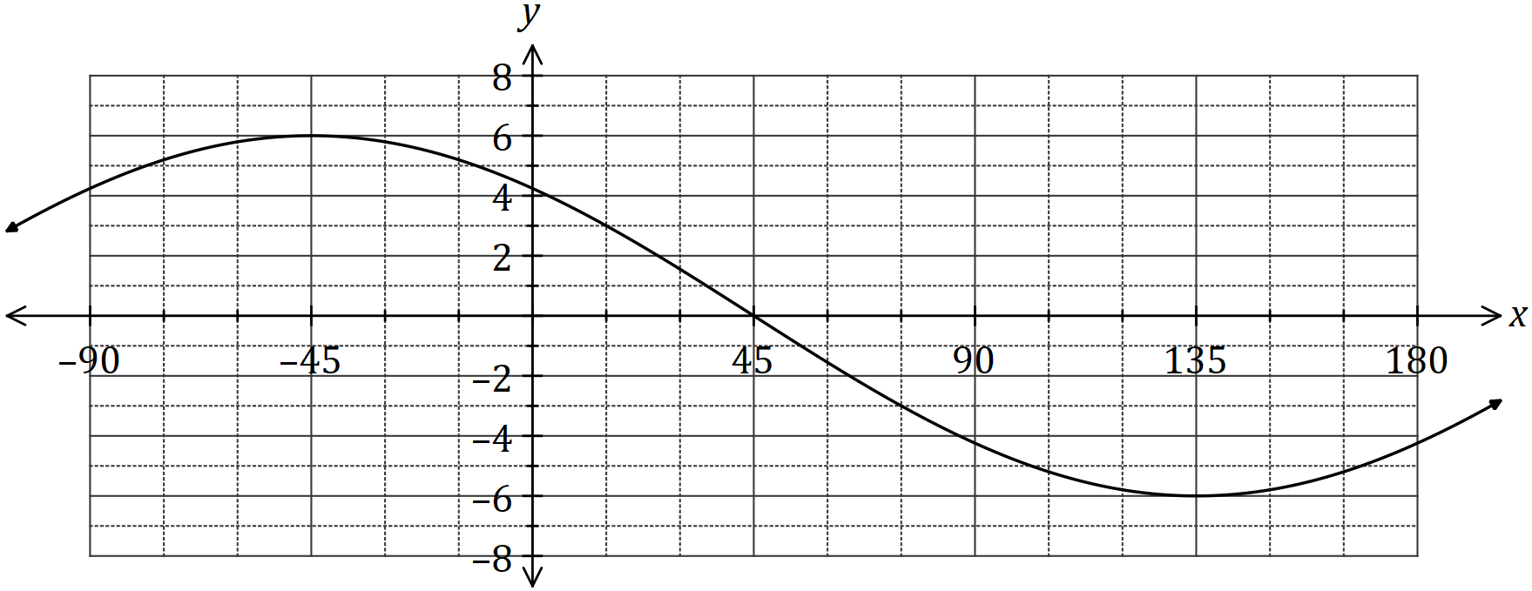

Determine the value of $a$ and the value of $b$, where $-90°≤b≤180°$. (2 marks)
Solution
$$a=6, b=45$$

Specific behaviours
value of $a$ ✓ value of $b$

(b) Given that $0°≤x≤360°$, solve

(i) $\cos{(x)}=\frac{1}{2}$. (1 mark)
Solution
$$x=60°, 300°$$

Specific behaviours
✓ correct solutions

(ii) $8\cos{(x+30°)}+4\sqrt{3}=0$. (3 marks)
Solution
$$\cos{(x+30°)}=-\frac{\sqrt{3}}{2}$$

$$x+30°=150°, 210°$$

$$x=120°, 180°$$

Specific behaviours
simplifies equation
✓ solves for angle sum
✓ correct solutions

Question 4 (7 marks)
(a) Determine the coordinates of the

(i) $y$-intercept of the graph of $y=4{\left(x-3\right)}^{2}-26$. (1 mark)
Solution
$$x=0, y=4{\left(-3\right)}^{2}-26=36-26=10$$

$$\text{At} (0, 10)$$

Specific behaviours
correct coordinates

(ii) turning point of the graph of $y=(x+4)(x-2)$.
(2 marks)
Solution
$$x=\left(-4+2\right)÷2=-1$$

$$y=\left(-1+4\right)\left(-1-2\right)=-9$$

$$\text{At} \left(-1, -9\right)$$

Specific behaviours
correct $x$-coordinate
correct $y$-coordinate

(b) The graph of $y=ax^{2}+bx+c$ is shown below. Determine the value of the coefficients $a, b$ and $c$. (4 marks)

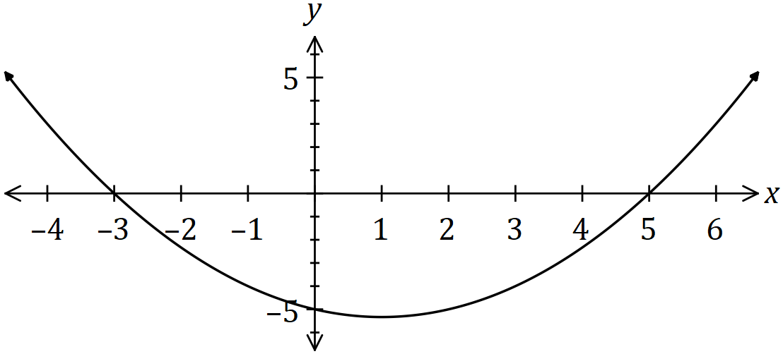
Solution
$$y=a\left(x+3\right)\left(x-5\right)$$

$$-5=a\left(3\right)\left(-5\right)⇒a=\frac{1}{3}$$

$$y=\frac{1}{3}\left(x^{2}-2x-15\right)$$

$$a=\frac{1}{3}, b=-\frac{2}{3}, c=-5$$

Specific behaviours
uses roots to write in factored form
✓ uses $y$-intercept to determine $a$
✓ expands quadratic
✓ states all coefficients

Question 5 (7 marks)
(a) Expand $x{\left(x+4\right)}^{2}$. (2 marks)

Solution
$$x\left(x^{2}+8x+16\right)=x^{3}+8x^{2}+16x$$

Specific behaviours
✓ expands quadratic correctly
correct expansion

(b) Let $f\left(x\right)=x^{3}+2x^{2}-5x-6$.

(i) Determine $f(2)$. (1 mark)
Solution
$$f\left(2\right)=2^{3}+2{\left(2\right)}^{2}-5\left(2\right)-6 \\ =8+8-10-6 \\ =0$$

Specific behaviours
correct value

(ii) Solve $f\left(x\right)=0$. (4 marks)
Solution
$$x^{3}+2x^{2}-5x-6=\left(x-2\right)\left(x^{2}+bx+3\right)$$

$$-5x=-2bx+3x⇒b=4$$

$$x^{2}+4x+3=\left(x+3\right)\left(x+1\right)$$

$$\left(x-2\right)\left(x+3\right)\left(x+1\right)=0⇒x=-3, -1, 2$$

Specific behaviours
uses (a) to write cubic as linear and quadratic factor
✓ determines entire quadratic factor
✓ factorises quadratic
✓ all correct solutions

Question 6 (7 marks)
(a) Briefly describe the behaviour of the $y$ values for each of the following graphs, given the behaviour of the $x$ values:

(i) $y=x^{4}$, as $x→∞$. (1 mark)
Solution
$$y→∞$$

Specific behaviours
describes correct behaviour

(ii) $y={\left(2-x\right)}^{3}$, as $x→∞$. (1 mark)
Solution
$$y→-∞$$

Specific behaviours
describes correct behaviour

(iii) $y=\begin{matrix}1 \\ \overline{x}\end{matrix}$, as $x→-∞$. (1 mark)
Solution
$$y→0$$

Specific behaviours
describes correct behaviour

(b) The graph of $y=f(x)$ is shown below. On the same axes sketch the graph of

(i) $y=f(x+3)$. (2 marks)

(ii) $y=f(3x)$. (2 marks)

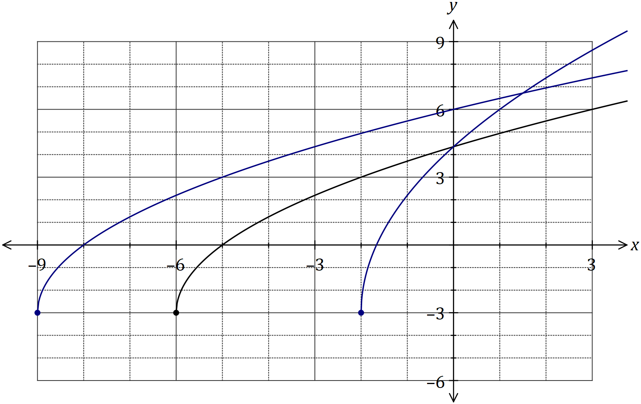
Solution (ii)
See graph
Specific behaviours
smooth curve starting at $(-2, -3)$
✓ same $y$-intercept as $f(x)$

Solution (i)
See graph
Specific behaviours
smooth curve starting at $(-9, -3)$
✓ intercepts at $(-8, 0)$ and $(0, 6)$

Question 7 (7 marks)
Line $L$ has equation $\begin{matrix}x \\ \overline{4}\end{matrix}+\begin{matrix}y \\ \overline{5}\end{matrix}=1$.

(a) State the coordinates of the point where $L$ intersects the $x$-axis. (1 mark)
Solution
$$y=0⇒x=4$$
$$\text{At} (4, 0)$$

Specific behaviours
correct coordinates

(b) State, with justification, if $L$ is parallel to the line with equation $y=0.8x+1$. (2 marks)
Solution
$$y=5-\frac{5}{4}x$$
$L$ is not parallel to this line as the gradients are different: $-\frac{5}{4}≠0.8$.

Specific behaviours
indicates gradient of $L$
✓ states not parallel, comparing gradients

(c) Determine the equation of line $P$ that is perpendicular to $L$ and passes through the point with coordinates $(50, 4)$. (2 marks)
Solution
$y-4=\frac{4}{5}\left(x-50\right)$ or $y=\frac{4}{5}x-36$

Specific behaviours
indicates perpendicular gradient
✓ correct equation

(d) Determine the coordinates of the point of intersection of $L$ and $P$. (2 marks)
Solution
$$P:y=\frac{4}{5}x-36$$

$$\frac{4}{5}x-36=5-\frac{5}{4}x⇒\frac{41}{20}x=41⇒x=20$$

$$y=\frac{4}{5}\left(20\right)-36=-20$$

$$\text{Intersect at} (20, -20)$$

Specific behaviours
equates equations and solves for $x$
✓ correct coordinates

Question 8 (7 marks)
(a) Evaluate $\sin\left(\begin{matrix}39π \\ \overline{ 4 }\end{matrix}\right)$. (2 marks)
Solution
$$\sin{\frac{39π}{4}}=\sin{\frac{\left(39-32\right)π}{4}}=\sin{\frac{7π}{4}}$$

$$\sin{\frac{7π}{4}}=-\sin{\frac{π}{4}}=-\frac{1}{\sqrt{2}}=-\frac{\sqrt{2}}{2}$$

Specific behaviours
reduces angle
✓ exact value

(b) $A$ is an acute angle and $B$ is an obtuse angle such that $\cos{A}=\begin{matrix}1 \\ \overline{3}\end{matrix}$ and $\sin{B}=\begin{matrix}2 \\ \overline{3}\end{matrix}$.

(i) Show that $\sin{A}=\begin{matrix}2\sqrt{2} \\ \overline{ 3 }\end{matrix}$ and determine the value of $\cos{B}$. (3 marks)
Solution 2
$\sin{A}=\frac{\sqrt{8}}{3}=\frac{2\sqrt{2}}{3}$

$\cos{B}=-\frac{\sqrt{5}}{3}$

Specific behaviours
indicates how to obtain $\sin{B}$
obtains $\sqrt{5}$
✓ correct value of $\cos{B}$

Solution 1
$$\sin^{2}{A}=1-{\left(\frac{1}{3}\right)}^{2}=\frac{8}{9}⇒\sin{A}=\frac{\sqrt{8}}{3}=\frac{2\sqrt{2}}{3}$$

$$\cos^{2}{B}=1-{\left(\frac{2}{3}\right)}^{2}=\frac{5}{9}$$

$$\cos{B}=-\frac{\sqrt{5}}{3}$$

Specific behaviours
indicates how to obtain $\sin^{2}{A}$
obtains $\cos^{2}{B}$
✓ correct value of $\cos{B}$

(ii) Determine the value of $\sin{(A+B)}$ as a single fraction. (2 marks)
Solution
$$\sin{(A+B)}=\begin{matrix}2\sqrt{2} \\ \overline{ 3 }\end{matrix}×\left(-\frac{\sqrt{5}}{3}\right)+\frac{1}{3}×\frac{2}{3} \\ =\frac{2-2\sqrt{10}}{9}$$

Specific behaviours
substitutes correctly
✓ correct value as single fraction

Supplementary page

Question number: _________

© 2019 WA Exam Papers. Kennedy Baptist College has a non-exclusive licence to copy and communicate this document for non-commercial, educational use within the school. No other copying, communication or use is permitted without the express written permission of WA Exam Papers. SN245-132-6.

